ABBREVIATED RESETTLEMENT ACTION PLAN | Local Economy and Infrastructure Development Project
SUB-PROJECT: Rehabilitation of Meghri Pokr Tagh (Small district) Tourism Infrastructure


April 2024
Contents
DEFINITIONS 3
INTRODUCTION 5
1.1 SUB-PROJECT OBJECTIVES 5
1.2 MAIN ACTIVITIES UNDER THE SUBPROJECT 6
1.3 EXPECTED IMPACTS AND APPLICABLE RESETTLEMENT INSTRUMENT 6
1.4. CENSUS SURVEY 7
1.4 PREPARATION OF ABBREVIATED RAP 7
2. COMPENSATION OF PAP 8
2.1 GENERAL PRINCIPLE OF COMPENSATION 8
2.2 COMPENSATION ELIGIBILITY AND ENTITLEMENTS ELIGIBILITY 8
2.3 RESETTLEMENT (RELOCATION) ASSISTANCE 8
3. PARTICIPATION AND CONSULTATION 9
3.1 CONSULTATION MEETINGS WITH PAPS AND INFORMATION DISCLOSURE 9
3.2 COMPLAINTS AND GRIEVANCES 9
4. COSTS AND BUDGETS 9
5. RESETTLEMENT IMPLEMENTATION 9
5.1 RELOCATION TIMELINE 9
5.2 RELOCATION OF PROJECT AFFECTED PERSON 10

List of Acronyms

AMD | Armenian Dram
ATDF | Armenian Territorial Development Fund
DFA | Development Foundation of Armenia
EIA | Environmental Impact Assessment
GoA | Government of Armenia
LEID | Local Economy and Infrastructure Development
MoEDI | Ministry of Economic Development and Investments
NGO | Non-Governmental Organization
OP | Operational Policy of the World Bank
PAP | Project Affected Person
RAP | Resettlement Action Plan
RAPIU | Resettlement Action Plan Implementation Unit created under LEID Project
RoA | Republic of Armenia
RPF | Resettlement Policy Framework
WB | World Bank

DEFINITIONS
The terms used in this document are defined as follows:
Compensation – loss reimbursement for Project Affected Persons. Includes payments in cash or in kind of the due amount (replacement value) in return for lost assets, property, resources, or income
Grievance redresses mechanism – the process established under the current Project to enable Project Affected Persons and communities to voice and resolve grievances related to project activities;
RAP Baseline survey – the population census, asset inventory, and socio-economic survey together constitute the baseline survey for the affected population;
Involuntary – refers to actions taken without the displaced person’s informed consent or power of choice;
Involuntary resettlement – refers to development project scenarios resulting in unavoidable resettlement losses, in which the people affected have no option but to rebuild their lives, income and asset bases elsewhere;
Project Affected Person or household (PAP) – refers to any person or household affected by project-related changes in use of land, water, or other natural resources. These include permanent or temporary losses of land, assets, and income. Affected persons, entitled to compensation or at least rehabilitation provisions under the Project are: all persons losing land, or access to land, permanently or temporarily either covered by legal title/traditional land rights or without legal status; tenants and sharecroppers whether registered or not; owners of affected buildings, crops, plants or other objects attached to the land; and affected persons losing business, income and salaries.
Relocation - the physical relocation of PAPs from their pre-project place of residence on either a temporary or permanent basis depending on the nature of project impacts (temporary or permanent). Includes replacement or rebuilding of housing, replacement or lost assets such as productive land and public infrastructure in another location;
Resettlement – in accordance with the World Bank’s Involuntary Resettlement Operational Policy (OP) 4.12, “resettlement” is a general term that refers to land acquisition and loss of assets, whether it involves actual relocation, loss of land, shelter, crops, assets or other means of livelihood. It includes all the measures taken to mitigate any and all adverse impacts of the Project on PAPs’ property and/or livelihood, including compensation, relocation (where relevant), and rehabilitation;
Resettlement Action Plan (RAP) – the planning document that describes what will be done to address the direct social and economic impacts associated with involuntary resettlement as per this RPF; An abbreviated RAP is a shorter form of resettlement action plan that can be done when expected impacts are not severe and affect few (e.g., fewer than 10) persons or households;
Resettlement Policy Framework - refers to the present document which is the overall Policy Framework for Resettlement of Project Affected Persons for the Local Economy and Infrastructure Development (LEID) Project. The Resettlement Policy Framework describes the process and methods for carrying out OP 4.12 policy under the Project, including compensation, relocation and assistance of persons whose assets or livelihoods are adversely affected by the Project;
Vulnerable groups (people) – project affected persons that face specific and additional constraints to cope with impacts of the project and require additional assistance to restore their assets or livelihoods, for example, persons living below the poverty line, elderly persons, persons with disability, families with many children or single-parent households, refugees and IDPs, etc. Vulnerable groups will be identified during the resettlement strategy planning process, and additional measures to assist them will be defined in the RAP.

INTRODUCTION
The Local Economy and Infrastructure Development (LEID) Project is the World Bank financed fifth project under implementation of ATDF. The Local Economy and Infrastructure Development project development objective is to improve infrastructure services and institutional capacity for increased tourism contribution to local economy in selected communities of Armenia.

The Project activities are expected to benefit the residents, tourists and enterprises in the regions of Armenia. Residents, tourists and enterprises are expected to receive improved access to, and quality of, public infrastructure; increased volume of private sector investment in the region; and increased small and micro enterprises in renovated cultural heritage sites and cities. The communities will benefit from increased overall tourism spending and satisfaction, job creation, improved institutional capacity of selected agencies, and improved capacity to operate and maintain assets.

“Rehabilitation of Meghri Pokr Tagh (Small district) tourism infrastructure” sub project is planned to be implemented under LEID project. The sub-project includes rehabilitation of historic paved streets of Pokr Tagh (Small district); improvement of the adjacent areas, including construction of the parking lot, provision of infrastructure and service elements that are necessary for the tourist area; rehabilitation of historic streets lighting, irrigation, and drinking water and sewerage systems. Most of the works envisaged under the sub-project are carried out in the historical and cultural zone of Meghri Pokr Tagh (Small district).

The purpose of the following Resettlement Action Plan is to provide general guidelines of adequate and efficient actions for the above-mentioned sub-project implemented under LEID to address minimize and mitigate adverse impacts of the sub-project activities. To mitigate any negative impacts on PAPs, this Abbreviated RAP was prepared in accordance with the WB OP/BP 4.12 and the RPF approved for the LEID project implemented by ATDF.

The main objective of development of RAP is to improve or at least restore the social and livelihood resources of the PAPs at their pre-project level. The process of implementation should ensure that this objective is achieved over a reasonable time with allocated resources. Therefore, monitoring of the process of RAP implementation and delivery of institutional assistance to the PAPs has been designed as an integral part of the overall functioning and management of the Project.

SUB-PROJECT OBJECTIVES
The overall objective of the Subproject is to restore the historical part of Pokr Tagh (Small district) of Meghri town:
- creating the necessary infrastructure to ensure the cultural, ethnographic, agro-eco-hosting conditions underlying the urbanization environment of the 18th-20th centuries;
- introducing Meghri town as a southern gateway from Iranian civilization to Armenian civilization;
- exploiting the economic, cultural and political role and significance of the city, based on the tourism potential of the area.

1.2 MAIN ACTIVITIES UNDER THE SUBPROJECT
The sub-project includes rehabilitation of historic paved streets of Pokr Tagh (Small district); improvement of the adjacent areas, including construction of the parking lot, provision of infrastructure and service elements necessary for the tourist area; rehabilitation of historic streets lighting, irrigation, and drinking water and sewerage systems. Most of the works envisaged under the sub-project are carried out in the historical and cultural zone of Meghri Pokr Tagh (Small district).

The subproject includes the restoration of Mezhlumyan and Vazants streets in Pokr Tagh (Small district) of Meghri town, which envisages the following works:
- Rehabilitation of asphalted and stone paved sections of both Mezhlumyan and Vazants streets and their branches;
- Rehabilitation of drinking water, sewerage and irrigation systems of both Mezhlumyan and Vazants streets and their branches;
- Construction of new retaining walls and reinforcement of the existing ones of both Mezhlumyan and Vazants streets;
- Construction of outdoor lighting system of both Mezhlumyan and Vazants streets;
- Establishment of a long-term parking lot adjacent to ​​Mezhlumyan street and a short-term one in the vicinity of Chinar (plane) tree area;
- Construction of a short-term rest zone near the water fountain of Chinar (plane) tree on Mezhlumyan street;
- Rehabilitation of two-story communal building near Chinar (plane) tree on Mezhlumyan street;
- Furnishing the Pokr Tagh (Small district) with tourist and road signs, benches and garbage cans.

1.3 EXPECTED IMPACTS AND APPLICABLE RESETTLEMENT INSTRUMENT
The sub-project will result in physical resettlement of one person. According to the WB OP/BP 4.12 and the RPF approved for the ATDF, the following Abbreviated RAP covers the following minimum elements:
- A census survey of displaced person and valuation of asset;
- Description of compensation and other resettlement assistance to be provided;
- Consultations with displaced owner about acceptable alternatives;
- Institutional responsibility for implementation and procedures for grievance redress;
- Arrangements for monitoring and implementation; and
- A timetable and budget.

An elderly woman lives in the “white” building to be rehabilitated under the sub-project. The building is the property of Meghri community. The woman will be provided with another shelter, a flat owned by the community and provided to her by Megհri community council decision for living by an agreement (the Meghri Community Council decision and the Agreement signed with the PAP are attached under Annexes 7 and 8). The resettlement was organized and financed by Meghri municipality under supervision and support of ATDF.

1.4. CENSUS SURVEY
The PAP is a 75-year-old woman, who resides alone in insufficient sanitary conditions. She is a recipient of benefits from the Poverty Family Benefit and old age pension systems. The sanitary conditions of her current place of residence are severely inadequate; lacking access to running water and kitchen facilities. The toilet facility is located outdoors in the yard.

1.4 PREPARATION OF ABBREVIATED RAP
The RAP complies with relevant Armenian laws and provisions of the WB OP 4.12 on Involuntary Resettlement, as well as Resettlement Policy Framework developed by ATDF for the LEID project.

2. COMPENSATION OF PAP

2.1 GENERAL PRINCIPLE OF COMPENSATION
The main principle for relocation of the PAP was allocation of an appropriate premises for living which will provide better living conditions compared to her current place of living. There were several options suggested by the municipality: a room in a community owned building with a bathroom of general use, 2-rooms in the communal area where the parking area will be built, an old house in “Pokr Tagh”, a room in a hotel.

The proposed options have been discussed with the PAP. The PAP refused some of the options and ATDF social team was against the hotel room which provided only short-term solution.

Finally, Meghri Community Council made a decision to purchase a flat as a community property (the decision of Meghri Community Council is attached under Annex 7) and to provide it to the PAP as a residence by an agreement (the Agreement is attached under Annex 8).

The municipality office administration expressed readiness to assist the woman during the relocation period. The municipality submitted a letter stating that all resettlement costs would be covered by Meghri municipality (see Annex 5). The Project-affected person agreed to the resettlement conditions, with the flat belonging to the Meghri community in Meghri town, with a size of 66.8m2, being provided to the PAPfor free use for an unlimited period (see Annex 6).

The sanitary conditions of the PAP are improved compared with the previous residence. There is running water and toilet in the flat which she lacked in the previous residence. The condition of renovation is also comparably better. The community also provided a TV set to the PAP. The photos of the flat are presented in Annex 1.

2.2 COMPENSATION ELIGIBILITY AND ENTITLEMENTS ELIGIBILITY
Affected household entitled for compensation under the Sub-project is Category III group according to criteria for eligibility which includes “those who have no recognizable legal right or claim to the land they are occupying”.

2.3 RESETTLEMENT (RELOCATION) ASSISTANCE
Temporary physical relocation of the PAP occurred due to the scope of the sub-project. The woman was relocated to a flat purchased by the community as a community property. The assistance for relocation was provided to the woman by Meghri administrative office.

3. PARTICIPATION AND CONSULTATION

3.1 CONSULTATION MEETINGS WITH PAPS AND INFORMATION DISCLOSURE
The first consultation meeting was conducted with the PAP on 23 December, 2021. The resettlement alternatives and suggestions were presented by the representatives of the Local Administration office of Meghri. The minutes of the consultation are attached. Another consultation meeting was conducted on January 16, 2024 with participation of ATDF Social Specialists of Environmental and Social Unit, Meghri community head and municipality staff, and residents of Meghri “Pokr Tagh”. Afterwards, there was a meaningful consultation with the PAP.

3.2 COMPLAINTS AND GRIEVANCES
In order to receive and facilitate the resolution of PAPs and beneficiary community members’ concerns, complaints, and grievances concerning the project performance a grievance redress mechanism is established to be used for addressing any complaints that arise during the design, RAP preparation and construction phases.
The grievance redress mechanism will address affected person's concerns and complaints proactively and promptly. A leaflet was given to the PAP with the contact information of the local focal point, ATDF hot line and ATDF social specialist contact information and other information on the GRM. The information on the GRM is posted on the information board of the municipality.

4. COSTS AND BUDGETS
Meghry municipality spent 5,340,000.00AMD to purchase a flat and allocate it to the PAP as a residence. This amount includes the price of the flat and taxes.

5. RESETTLEMENT IMPLEMENTATION

5.1 RELOCATION TIMELINE
The relocation of the PAP was organized in accordance with the following timeline:
RAP IMPLEMENTATION TIMELINE
# | Activity | Implementation Period | Implementing Parties
1 | Draft RAP preparation including first PC meeting | 2021-2023 | ATDF
2 | Second PC meeting on draft ESMP and RAP including meaningful consultation with the PAP | January 2024 | ATDF and Meghri Municipality
3 | Meghri Community Council decision for purchase of a flat and its allocation to the PAP for free use for unlimited time period | February 2024 | Meghri Municipality
4 | Agreement signed with the PAP for relocation | February 2024 | Meghri Municipality and PAP
5 | Relocation of the PAP | March 2024 | Meghri Municipality

5.2 RELOCATION OF PROJECT AFFECTED PERSON
After reaching an agreement with the PAP on the conditions of resettlement, the municipality office administration assisted the woman during the relocation period. The relocation of the PAP was organized in the beginning of March 2024, prior to the commencement of civil works in Meghri.
The ATDF staff conducted a monitoring visit to the PAP in her new residence to observe the living conditions and to obtain feedback from the PAP. The PAP is content with the new conditions. Similar monitoring visits will be conducted twice a year until the end of the Project, and information related to these visits will be reflected in the progress reports.
ANNEX 1. PHOTOS OF LIVING CONDITIONS OF THE PAP BEFORE AND AFTER THE RESETTLEMENT

Previous Living Conditions
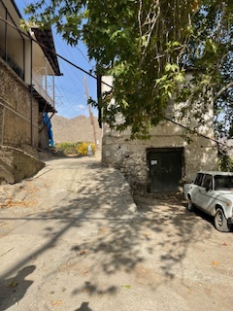 | 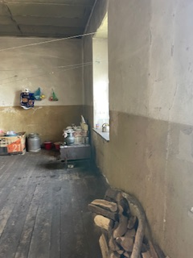 | 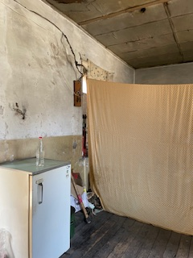
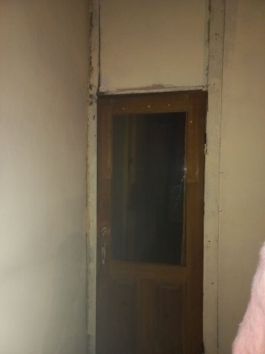 | 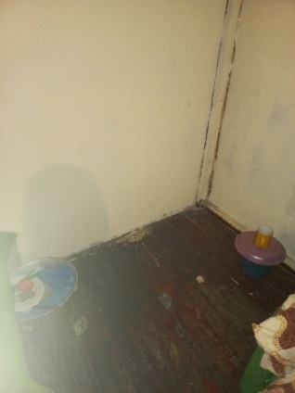 | 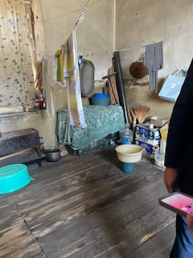

New Living Conditions

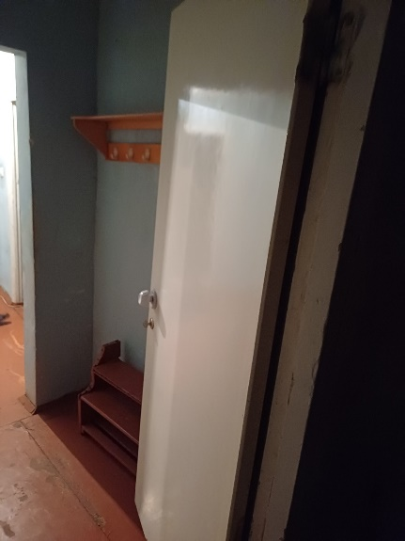 | 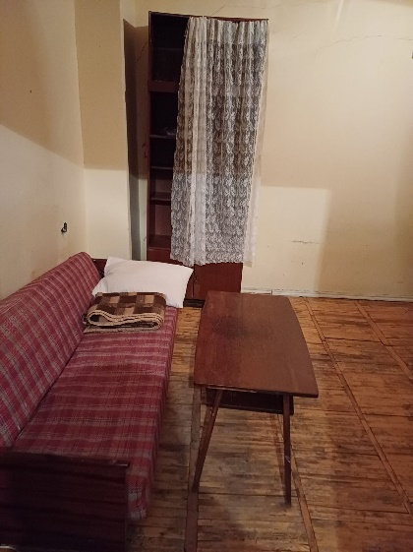 | 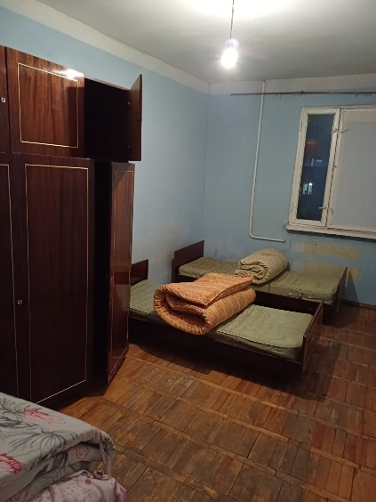
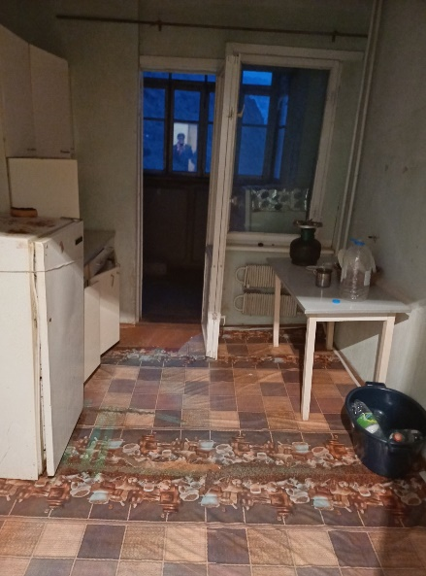 | 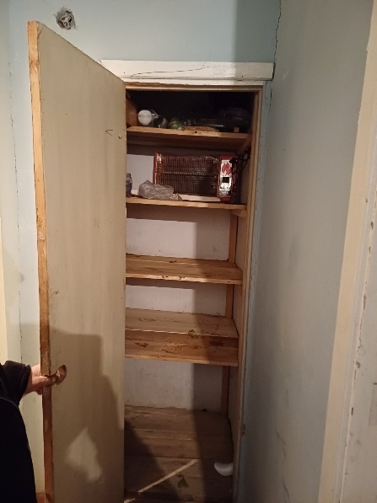 | 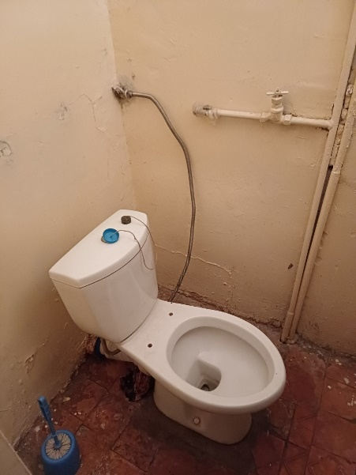
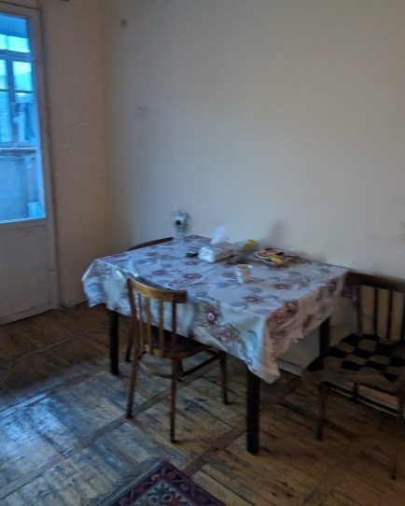 | 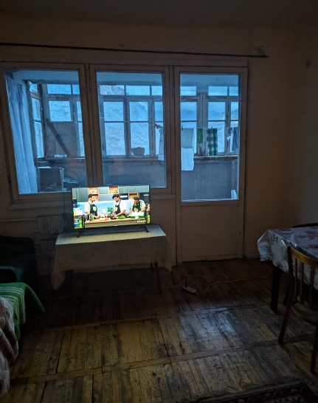

ANNEX 2. PHOTOS OF THE CONSULTATION WITH THE PAP

The photos and the list of participants are not subject to publication

ANNEX 3. MINUTES OF THE FIRST PUBLIC CONSULTATION
Non official translation of the original document

Summary of the above document
The representatives of the Meghri Administrative office and the PAP participated in the consultation meeting held on 23 December, 2021 in PAP’s place of residence in Meghri.
The deputy head of Meghri community presented the sub-project scope and the expected social impacts including the need for relocation of the PAP to another community owned building with better sanitary conditions. Levon Mirzoyan suggested allocating one room apartment with 20sq.m area as compensation. The room will be renovated; the windows and doors will be replaced, running water, sink, and built-in closet will be provided. The PAP will also be provided with firewood (3 cubic meters) to heat the room in the winter.
The PAP presented her requirements and agreed on the suggested resettlement conditions and compensation.

ANNEX 4: MINUTES OF SECOND PC MEETING
(Discussion about the PAP is presented below in blue italics)
On January 16, 2024, a public consultation meeting was held in the municipality of Meghri community with the participation of ATDF specialists, the head of Meghri community, and residents of “Pokr Tagh” district of Meghri town. Overall, 22 people participated in the meeting, of which 6 were women.
The announcement of the public consultation meeting and the draft ESMP were posted on the webpages of the ATDF and Meghri community on January 3, 2024․
Bagrat Zakaryan, the head of Meghri community, opened the meeting and presented the purpose of the meeting and the concept of the sub-project.
Marine Vardanyan, the Social Specialist of the Environmental and Social Unit of the ATDF, informed the participants that the ATDF had prepared an Environmental and Social Management Plan (ESMP) for sub-component “Rehabilitation of Meghri Pokr Tagh (Small district) tourism infrastructure”. The public consultation meeting was held in Meghri to disclose the draft ESMP to the community so that the community could raise their concerns and make suggestions. She noted that the ESMP includes all possible environmental, social, health and safety impacts and their mitigation measures to be implemented during the construction works.
Marine Vardanyan presented the expected temporary environmental and social impacts, including the generation and transportation of construction waste, noise and dust generation due to construction works. The safety measures to be provided were also presented, including the fencing of the construction site, installation of caution tapes in dangerous areas of the construction site and traffic management, as well as the safety signs installation requirements. The measures for safety of labor were presented, including wearing uniform and personal protective equipment, as well as the requirements on the supply of construction materials and maintenance of construction equipment.
Marine Vardanyan mentioned that no negative social impacts are anticipated under the project. However, there is a case for resettlement which she talked about later during the meeting. It was also mentioned that in cases when the stone fences of the residents of Vazants street had to be removed and renovated, written consent of the owners had to be taken from the owners beforehand.
Sona Gevorgyan, the Social Specialist of the Environmental and Social Unit of the ATDF, presented the Grievance Redress Mechanism (GRM) of the LEID project to the participants of the meeting. She also noted that the community had to appoint a GRM focal point who would be responsible for recording the grievances from the community and to pass them to the ATDF. She also added that the GRM focal person’s contact information should be available for the community. It was mentioned that the information on the GRM will be additionally posted on the information board of Meghri Municipality and the sub-project information board to be installed at the entrance of the construction site.
Thus, Mariam Hakobyan, the PR officer of the Municipality was appointed as the GRM focal point for Meghri sub-project. And the GRM information was placed on the info board immediately after the meeting and was posted on Meghri community website.
Marine Vardanyan also presented the supervision and monitoring procedures for the implementation of the measures provided under the ESMP were explained.

There was also a discussion about the resettlement of the PAP who has been residing in the community building included in the subproject for rehabilitation and use as an info center. Marine Vardanyan noted that the municipality has undertaken the responsibility for resettlement of the old woman to other premises with better communal conditions compared to her current conditions.
Bagrat Zakaryan informed the participants that the PAP had refused to move to the suggested 2 premises (in a hotel and in the territory of the communal services) so now the municipality is in search for a proper apartment that can be rented for her.
Marine Vardanyan reminded the participants and the mayor that the condition of the suggested premises should be better than that of her current place and there should be written obligation from the municipality that the woman could live at the new place all her life.
There were no questions related to environmental, social, health and safety impacts and their mitigation measures. However, there were lots of questions about the design solutions so the community head presented some details about the design. The main questions were as follows:
Q1 – What kind of stone will be used at stone paved sections?
A1 – It will be basalt but the stones will not be smoothly polished tiles but roughly grounded pieces.
Q2 – Is the rehabilitation of old houses in “Poqr Tagh” included in the sub-project?
A2 – No, apart from the rehabilitation of community owned two-storied building on Mezhlumyan Street.
Q3 – Does the sub-project include underground reinstallation of the gas pipes?
A3 – The question was raised also during the EIA meetings, but it was impossible to include in the design as the gas pipelines have to be installed on safe distance from houses which cannot be kept in case of underground installation.
After the meeting the ATDF Social specialists visited the PAP and talked to her. She confirmed her readiness to move to another flat rented by the municipality or even to the hotel if all the arrangements for her stay there are provided.

The photos and the list of participants are not subject to publication.

ANNEX5: STATEMENT OF THE MEGHRI MUNICIPALITY
Non-official translation of the statement
The Meghri municipality does not have any legal agreement with the woman living in the community owned one-story building located in the "Pokr Tagh" historical and cultural district of Meghri.
The Meghri Municipality is committed to provide another one-room house owned by the Municipality, renovate the new house by Meghri community means, improve living conditions, and organize the resettlement of the woman to a new house by the end of the sub-project final appraisal.
Signed by the head of Meghri community
Bagrat Zakaryan

ANNEX 6: CONSENT OF THE PAP
Non official translation of the original document

Summary of the above document
Me, (name of the PAP) agree to move to the room located in the building of the former boarding school located at 6 Melik Ohanjanyan Street provided to me on the bases of termless use.

However, this option for relocation of the PAP changed and the old woman was offered better conditions for living: a separate flat (see Annexes 7 and 8).

ANNEX 7: MEGHRI COUNCIL DECISION FOR ALLOCATION OF A FLAT FOR FREE USE
Non official translation of the original document

RA SYUNIK MARZ MEGHRI COMMUNITY COUNCIL
DECISION
19 March, 2024 #26-A
Based on point 21 of section 1 of the Article 18 of the RA Law on “Local Governance Bodies” and provisions of 36 Chapter of the RA Civil Code, Meghri Community Council Decision of February 15, 2024, #14-A, and Meghri community head’s suggestion, Meghri Community Council decides:
- To provide the flat belonging to Meghri community to the PAP for free use for non-limited period.
- The community head to ensure the implementation of functions derived from this decision.
The decision was made with all 10 members voting “For”.
Signed by Meghri Community Head B. Zakaryan

ANNEX 8: FINAL CONSENT OF PAP
Non official translation of the original document

Statement
I, (name of the PAP and Passport number) agree to relocate to the flat allocated to me by the community in Meghri town for free use for non-limited period (permanent). I was informed about the relocation conditions during the meeting and discussion with me on February 29 held by the Chairman, deputy chairman and members of the RA Syunik Marz Meghri Community Commission for ensuring social support services improvement procedure and provision of social services to socially insecure and vulnerable families and those who appeared in difficult life situation. As a result of this discussion I provide my agreement which is signed by me and the Chairman, deputy chairman and members of the RA Syunik Marz Meghri Community Commission for ensuring social support services improvement procedure and provision of social services to socially insecure and vulnerable families and those who appeared in difficult life situation.
Signed be the PAP
And
Chairman, deputy chairman and members of the RA Syunik Marz Meghri Community Commission for ensuring social support services improvement procedure and provision of social services to socially insecure and vulnerable families and those who appeared in difficult life situation
7 signatures

